**ASSIGNMENT 1, SUBMISSION 2 – CMPU4063**

**Emma Carolan D17124464 DT9420**

Contents

**1 Design (20%) – Submission 1 (Submitted 19/11/18) 1**

**2 Implementation (60%) – SUBMISSION 2 2**

**3 Test & Evaluation (20%) – SUBMISSION 2 5**

**4 Further Evaluation and Testing Undertaken 9**

**5 Further Development 11**

# Design (20%) – Submission 1 (Submitted 19/11/18)

# Implementation (60%) – SUBMISSION 2

* 1. Create your website using HTML/CSS/Javascript** based on your paper prototypes.
     1. Use of CSS:
        1. All of your own CSS must be in mystyles.css
* All CSS saved in mystlyes.css
  + - 1. If you use a framework all adjusted code must be marked as **/*CHANGED*/**
* No framework used as such, however all adjusted code is marked as /*CHANGED*/ and commented
  + - 1. Correct use of external style sheet(s)
* External style sheet used for CSS and is contained in the LINK element in the head of each HTML page. LINK element code is as follows: <link rel="stylesheet" type="text/css" href="newcss.css">
  + - 1. Correct definition and use of classes, ids and pseudo classes (where necessary)
* Many classes have been created which allows only elements within that class to be styled or affected. Examples of classes used are a blog class and side1 class which will contain a Google Map. HTML elements can also have more than one class and I have used this feature several times e.g. header and footer classes are also ‘item’ class.
* An ID selector has been used for the myBtn ID in the CSS which ensures that only the html element with this ID will be styled.
* Pseudo classes can be used to define the special state of an element. I have used pseudo classes for the anchor tag and as such the links can be displayed in different ways depending on mouse movement. This includes using CSS to display an unvisited link, visited link, a link when hovered over and a link when selected. I have used hover and active for several classes including anchor, .fa and #mybtn ID.
  + - 1. Correct definition and use of element tags in style sheet (where necessary)
* Many element tags and selectors used to style individual parts

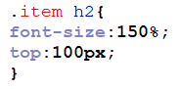 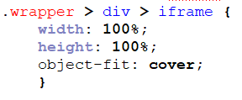 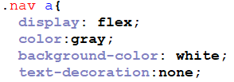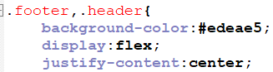

* + - 1. Use of CSS3
* Border radius has been used on the social media icons in order to change the display from a more severe 90 degree angle to a slightly rounded edge using the code below.

This property could also allow the creation of circles if required.



* Box shadow has been used for the blog class in order to give each section some depth and distinction on the page



* Media Queries have been used in order to tailor the design of the website to different screen sizes, i.e. iPhone, iPad, Macbook. Although media queries were in use with CSS2, this was only to the extent that it allowed for different media types for example printers, computer screen. However CSS3 now allows another value of “screen” to be implemented within the Media Query and as such the width or height of the viewport or device can be checked in the media query. I have used width with the screen value in order to check for minimum width to cater for a given screen size. Further development of this website would also allow for orientation i.e. landscape, portrait to be checked.
  + 1. Use of HTML:
       1. Correct page set up (e.g., <html>, <head>, <body>....)
* HTML pages have been set up appropriately including correct use of meta tags, link and title tags in the HEAD and correct use of Head and body tags with wrapper class and main content in the body. This includes the appropriate use of Link tags to link relevant external stylesheet and icons and buttons.
  + - 1. Correct use of tags
* Appropriate tags have been used with anchor href tags and image tags placed within the div. Also many classes have been used correctly within these divs including classes to locate items on the grid, video tags, h2 tags and alt tags have been included for all images.
  + - 1. Use of HTML5 tags
* There are many new elements in HTML5. In terms of structural elements, I have used html5 tags for Header, Footer and Nav and these tags now define the appropriate element. In terms of media elements, I have used the video tag which defines that it is a video and supports mp4.
  + - 1. Adequate tags chosen
* Where possible I have used img tags as opposed to using inline css style on the html page. It is easier to use the alt tags through use of img tags. However, in certain instances, e.g. gallery.html I have used inline css style in the html in order to use background image. In both instances however I have chosen not to include any images in the external css as this provides more flexibility.
  + - 1. Content appropriate for the website theme chosen
* The HTML Content fits the theme of the website which is travelling. This includes many images the majority of which are taken by me, several videos the content of which is relevant to each page and relevant accompanying text to different sections. Social media buttons have also been included (appearing at different locations depending on screen size) which also fits the theme and allows the user to find out further information about the authors travels. (I have linked these to my own accounts but the idea would be that they be linked to a business account)
  + 1. How does use of HTML and CSS code address responsiveness?
* The grid format chosen which is CSS Grid is the primary role of addressing responsiveness.
* Image responsiveness, which is also discussed further in the report in part v plays a large role in the responsiveness of the site……
* As part of the CSS grid layout, I have included a responsive row design which means that different sized elements can be catered for in the grid. Show code and give example of a page
  + 1. Use of JavaScript: There should be at least **two** scripts used in the website. At least one of these should be your own code. These should be described in your report.
* The first javascript used I have taken from w3schools and is the button which allows the user to go back to the top of the page once the user has already scrolled down 20 pixels. This involves the use of a HTML button, CSS styling which includes the #mybtn ID. The javascript contains two functions, one scrollFunction which shows the button when the user has scrolled 20px and another topFunction which when the user clicks the button the document goes back to the top. The script is contained at the end of the html in order to help improve speed.
* The second javascript is my own code and is found on each html page and is used to ask the user if they want to comment or question via email. The user must enter their name and the script validateFrom is used to ensure they have entered it showing an alert if not and also an hello alert when have successfully entered their name asking them to send an email. This email is controlled in a Form in the html where an action is used to automatically send the email to my email address and connect via the users mail server.
  + 1. Use of images: there must be a suitable strategy for dealing with images responsively. These should be described in your report.

Max-width, cover,contain,also using inline css for style of background image – also why was background chosen as opposed to img tag

* + 1. Use of other technologies:
       1. At least two of the following list should be incorporated within your website:
          1. Videos
          2. Audio
          3. iframes
          4. Use of forms
          5. ….any other technologies that have not been covered in class
* I have included an iframe on each page which embeds a Google Map relevant to the particular page. The iframe is contained in a div and is part of a class which displays it in a certain part of the grid. The iframe code is obtained from Google Map website Share or Embed map option and copied.
* I have also included videos in different formats. On the main index page, the video is an mp4 format and is accessed via the html video tag which specifies the name of the mp4 to access. Other videos have been incorporated on other html pages by embedding iframes from YouTube videos.
* I have also used a Form in each html as explained in the javascript section above (iv).
  + - 1. Do the chosen technologies fit in with the theme of the web site?
* The iframe for Google Map fits theme as it is a travel site and therefore I felt it would be useful for the user to have a map accessible to them relevant to each location without having to separately look up. The videos are also fitting as they provide the user with a short clip of the information including sound which is Spanish music, so it is appropriate to the theme and also provides extra information while sticking to the feel of the website.

# Test & Evaluation (20%) – SUBMISSION 2

* 1. State the following:
     1. Number of lines of your own CSS code
* 440 lines of CSS code
  + 1. Number of lines of adjusted CSS code
* Lines 42-96 are adjusted code or code that has been amended from w3 schools or taken from you tube code pens.
  + 1. If you have used a CSS framework:
       1. What is it?
       2. How can it be accessed?
       3. Why did you use it?
* A CSS framework has not been used. CSS Grid has been used throughout as explained in Part 1 submission. This was chosen in order for me to learn this layout and as it very flexible and responsive with little coding required in the mark-up. I also researched the benefits of CSS Grid through many tutorials on you tube e.g. Rachel Andrews and Jen Simmons and I believe the benefits and flexibility outweigh existing frameworks. Ref Part 1 Submission, 5. Grid.
  1. Use **one** method for testing how fast your website is:
* I have used Google Developer Pagespeed Insights to test the speed of my html pages. This returns a speed score from 1-100 for both Mobile and Desktop and advises where there are opportunities for optimisation and provides a diagnostic.
* In addition as I hosted my website this showed me an issue with speed straight away as I had designed grids to display background colours for testing purposes and when the site loads from the server you can see that the colour displays slightly before the image is rendered – this does not happen of course when testing on PC and harddrive.
  + 1. State how fast your website is.
    2. Implement and document one change to improve the speed.
    3. State how fast your altered website is.

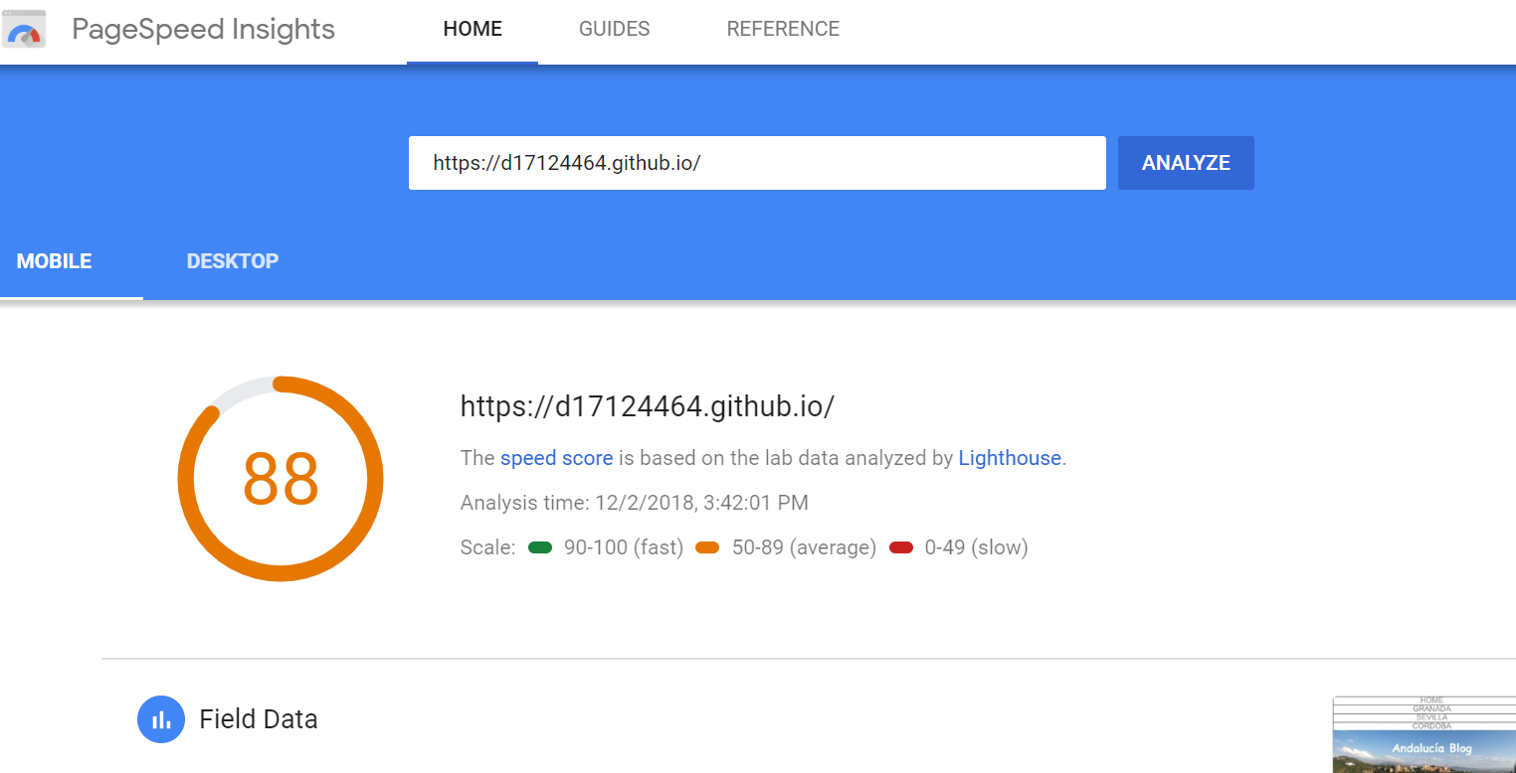

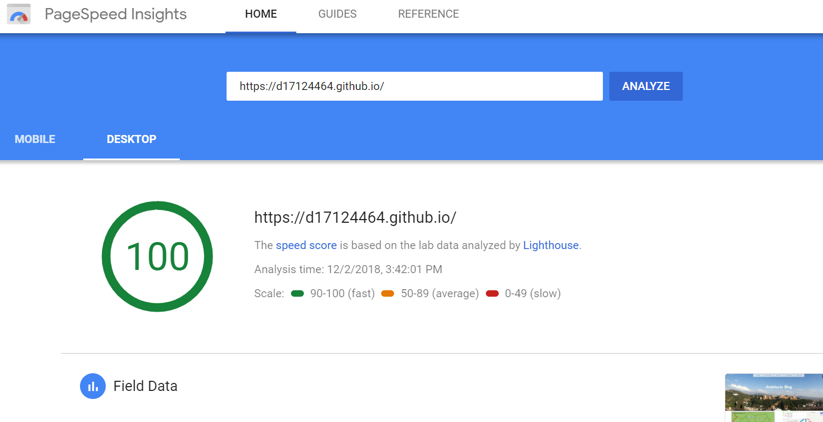

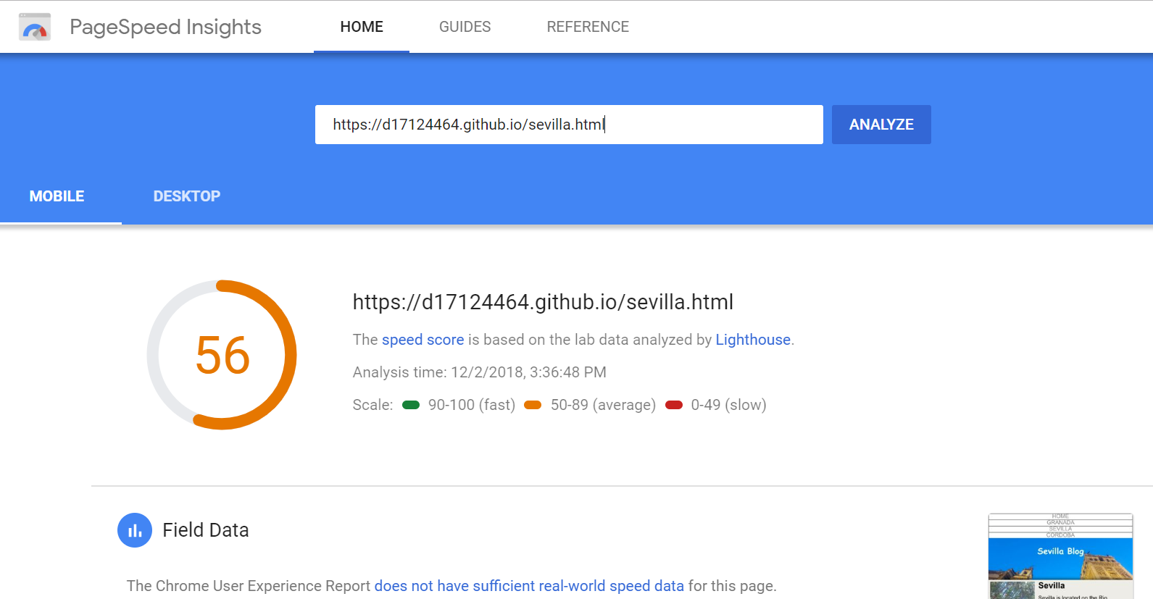

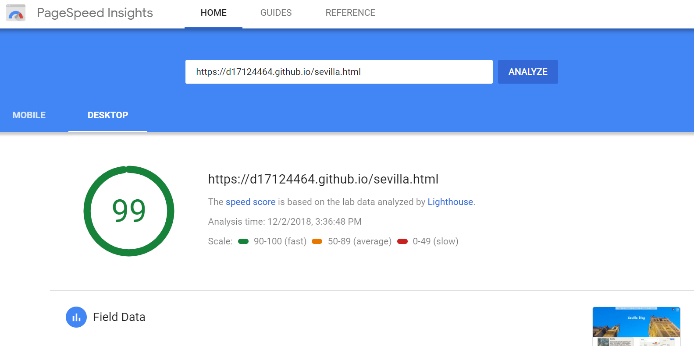

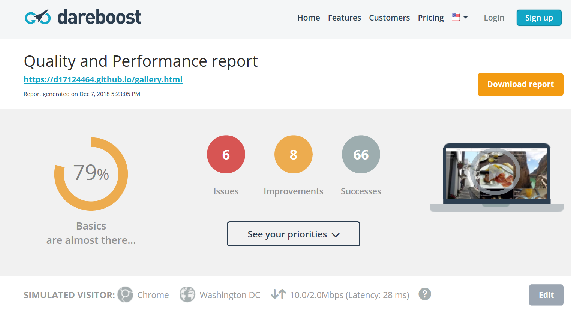

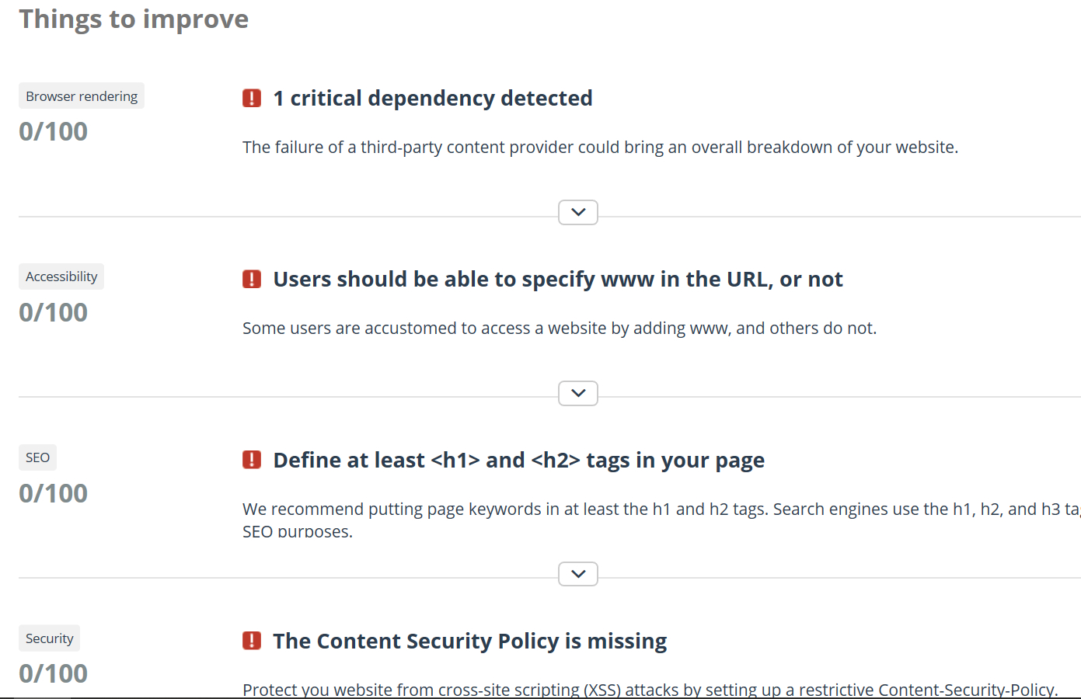

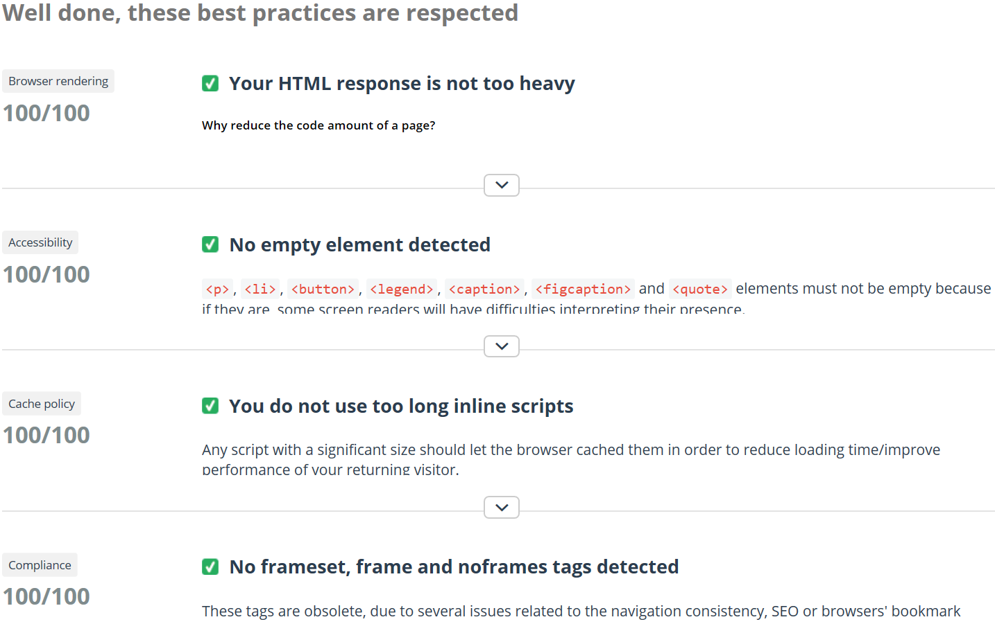

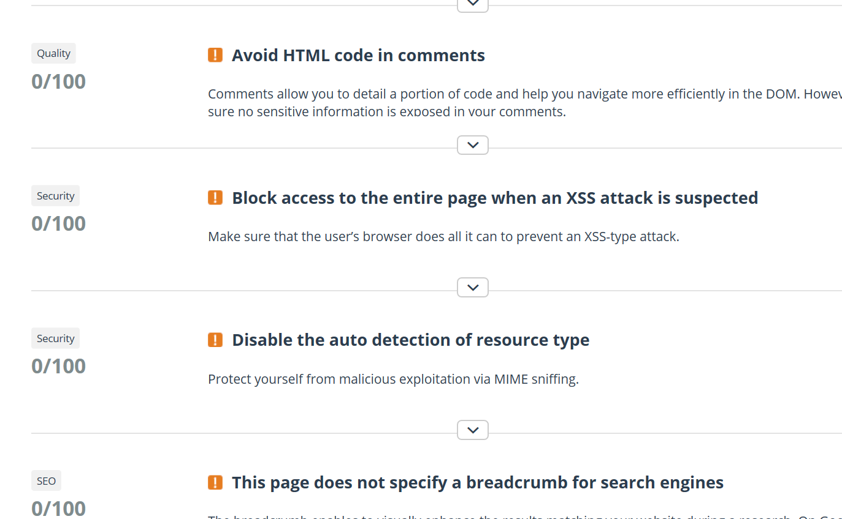

<https://wordpress.org/plugins/imsanity/>

* 1. Use **one** method for testing how responsive your website is.
* I have used Developer Tools in Chrome in order to test website responsiveness. This facility allows you to choose from many different screen sizes and display the website accordingly.
* I also used <http://quirktools.com/screenfly/> in order to check screen sizes prior to hosting the site. I found Developer Tools to be the most useful both in terms of checking for responsiveness and for inspecting various elements in the code, in particular when inspecting the grid elements, see below.

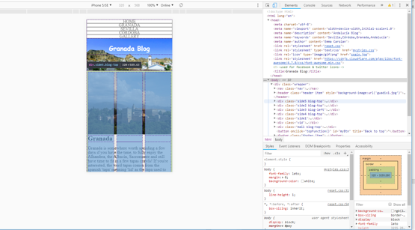

* Subsequently, I have also hosted the website to Github <https://d17124464.github.io/> which means full responsiveness testing can be carried out on various devices and I have tested the site on my own Samsung A3 phone, my iPad and HP 14” laptop. Images of my hosted site displayed on Samsung phone below.

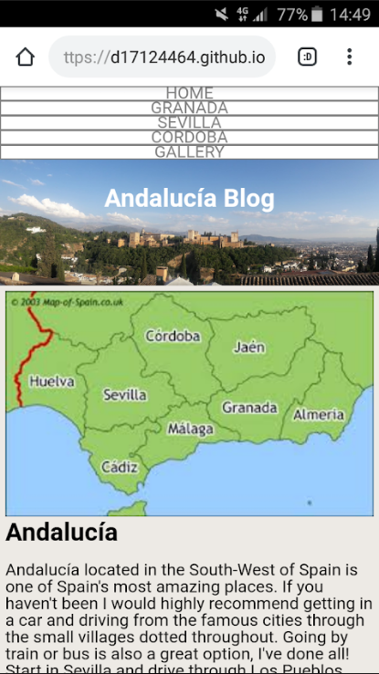 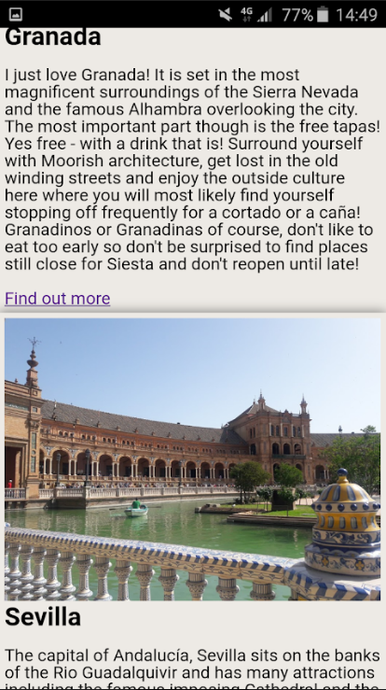 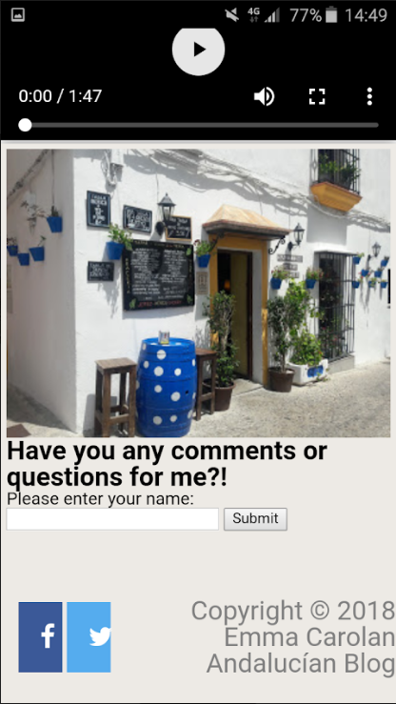

* 1. Use **one** evaluation method to assess the usability and functionality of your website.
     1. Description of evaluation methods e.g., survey, interview, expert review … and why they are appropriate

Evaluation method chosen – survey.

Display results.

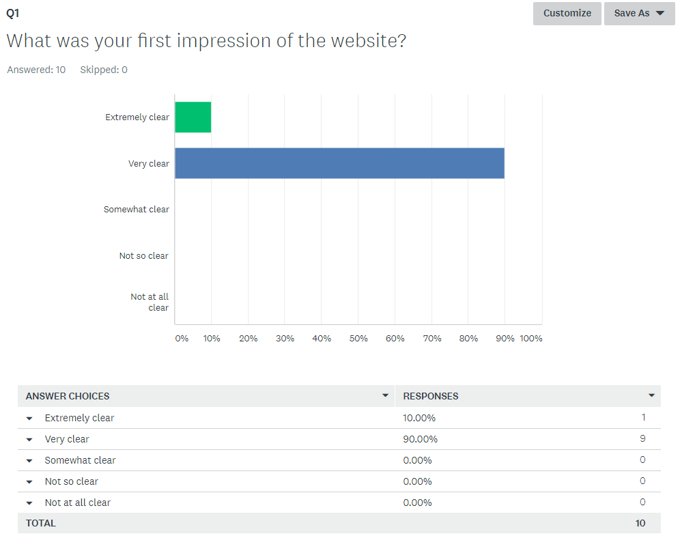

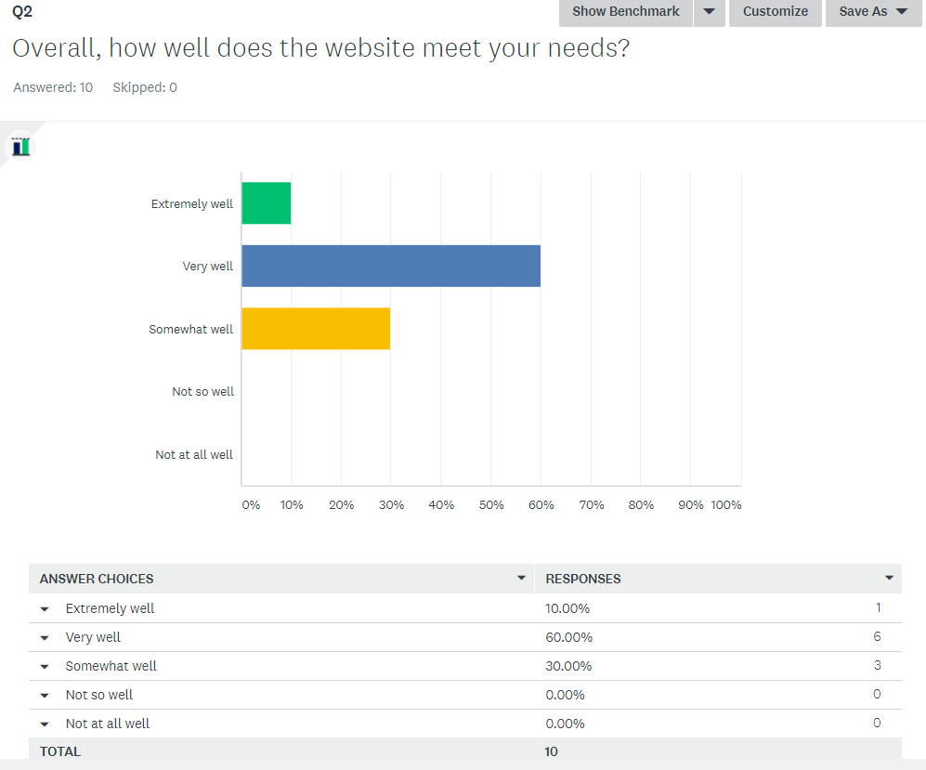

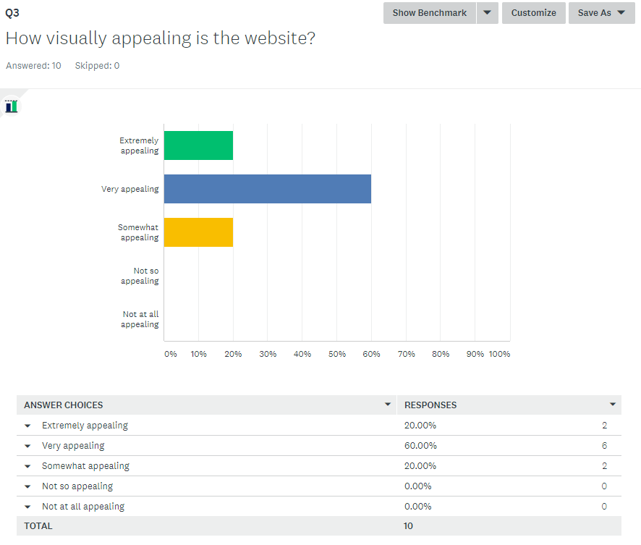

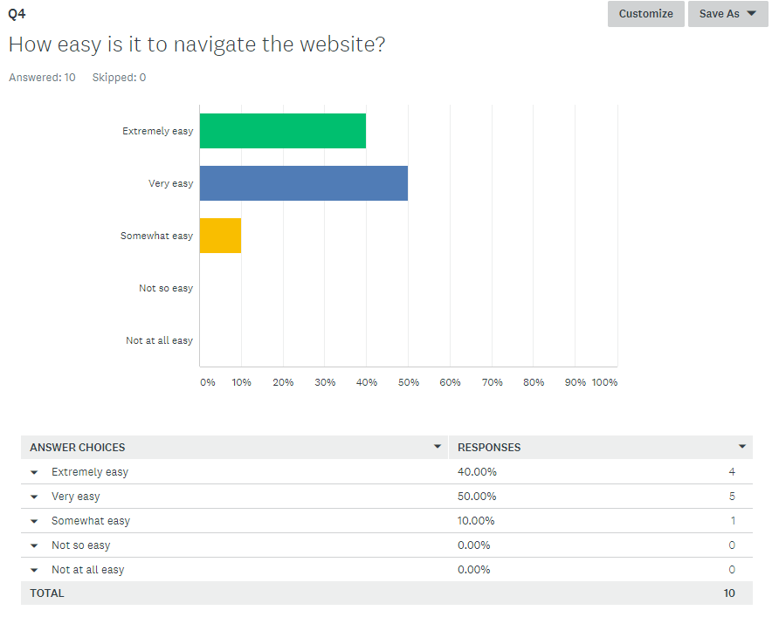

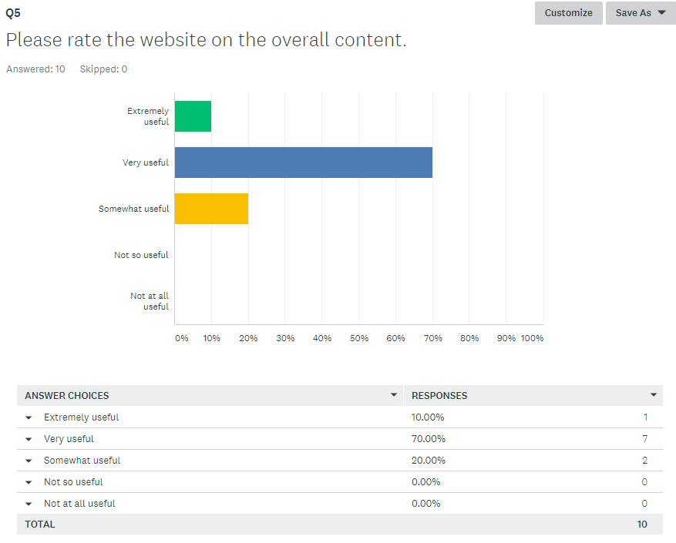

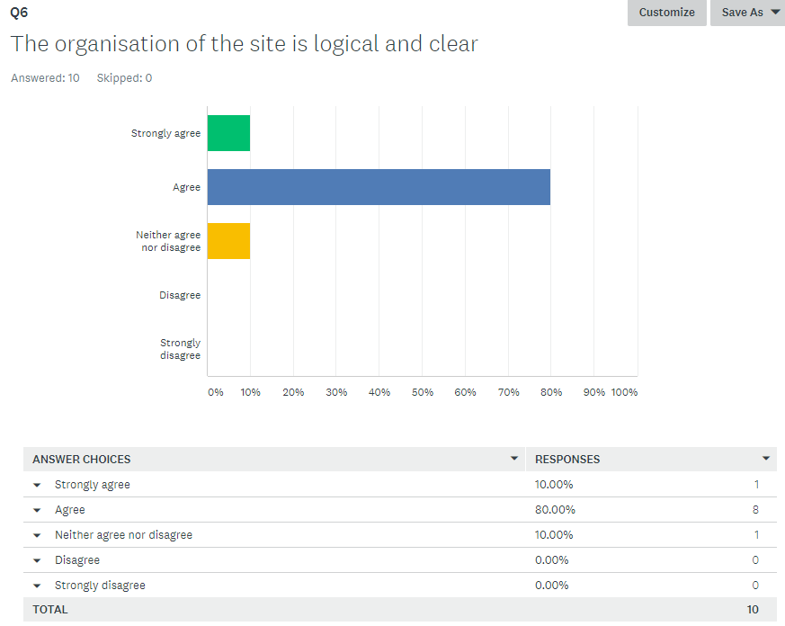

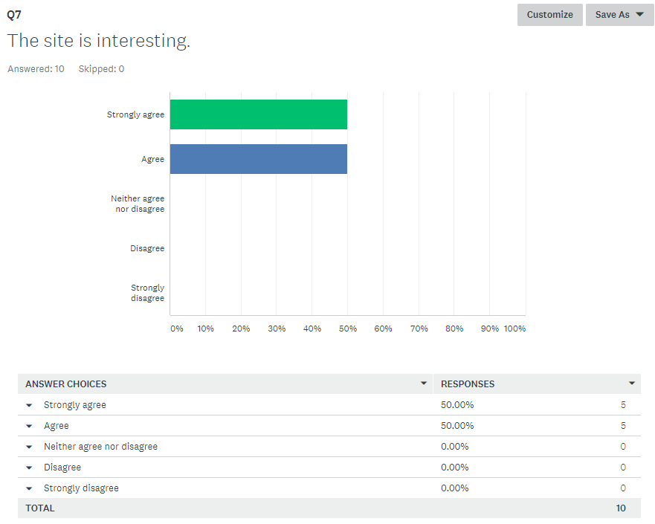

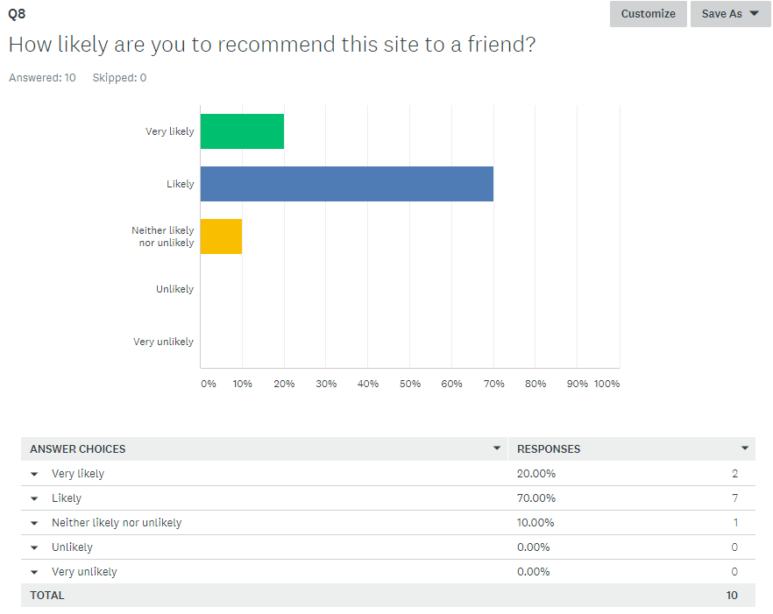

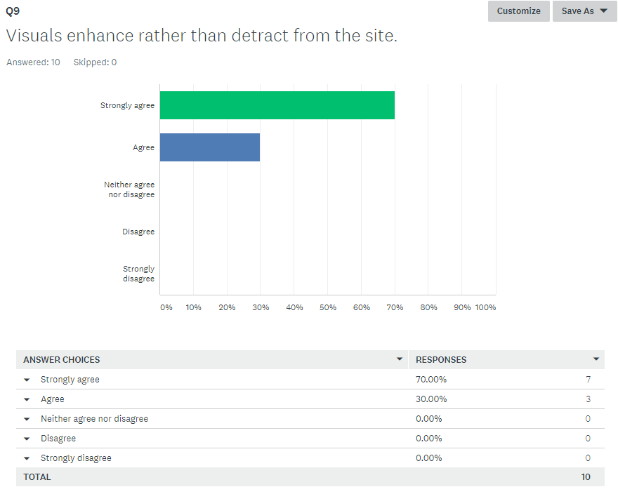

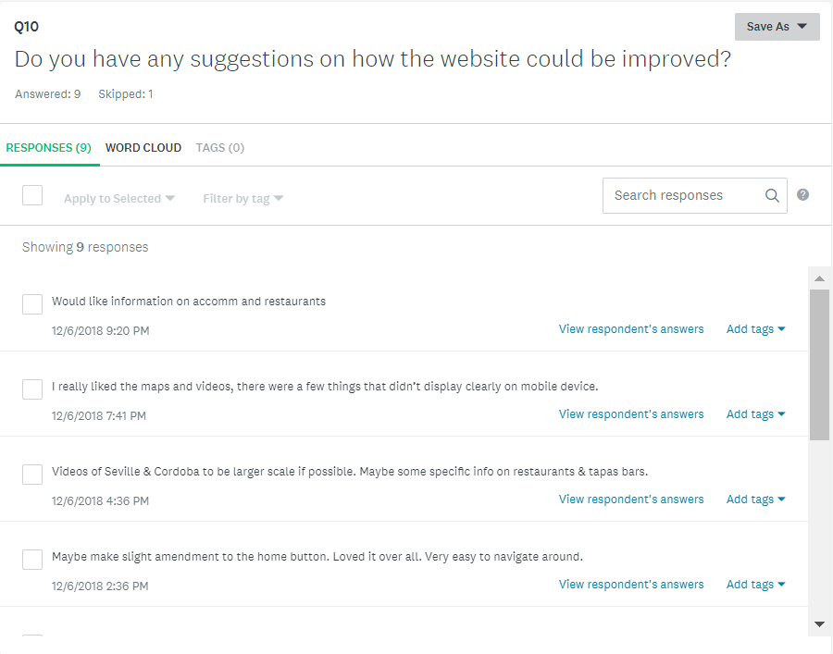

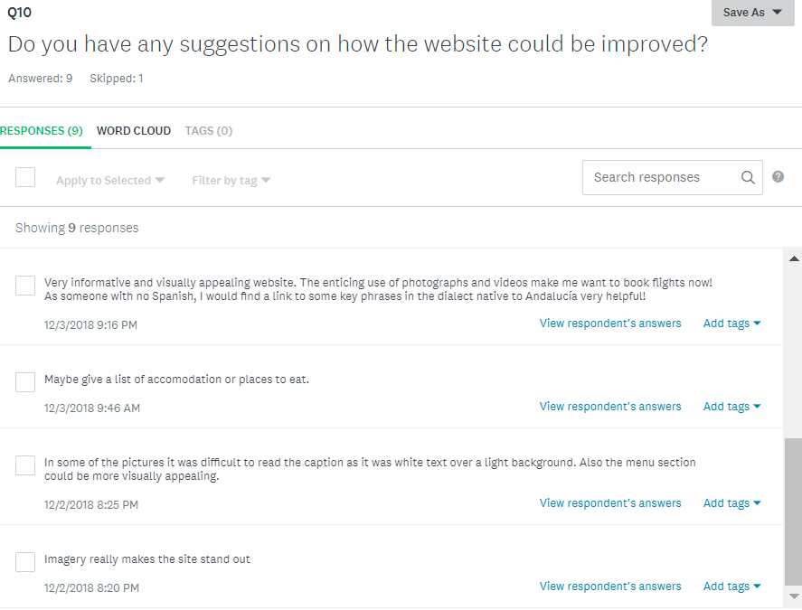

* 1. Outcome of test and evaluation:
     + 1. How did your web site fare?
       2. How was it mobility-wise?
       3. What are the recommendations if the web site was going to be developed further?

# Further Evaluation and Testing Undertaken

* Browser testing – IE issues with grid, does not allow for current CSS grid specification
* Same browser different pc issues
* Version 70.0.3538.110 Google Chrome
* Microsoft Edge 42.17134.1.0
* Ipad and iphone issues even though developer tools show display correctly for video
* I have tested HTML markup using HTML validator <https://validator.w3.org/>

Testing <https://d17124464.github.io/> which is index.html returned 7 errors in markup, however after fixing these only 1 remained see below.

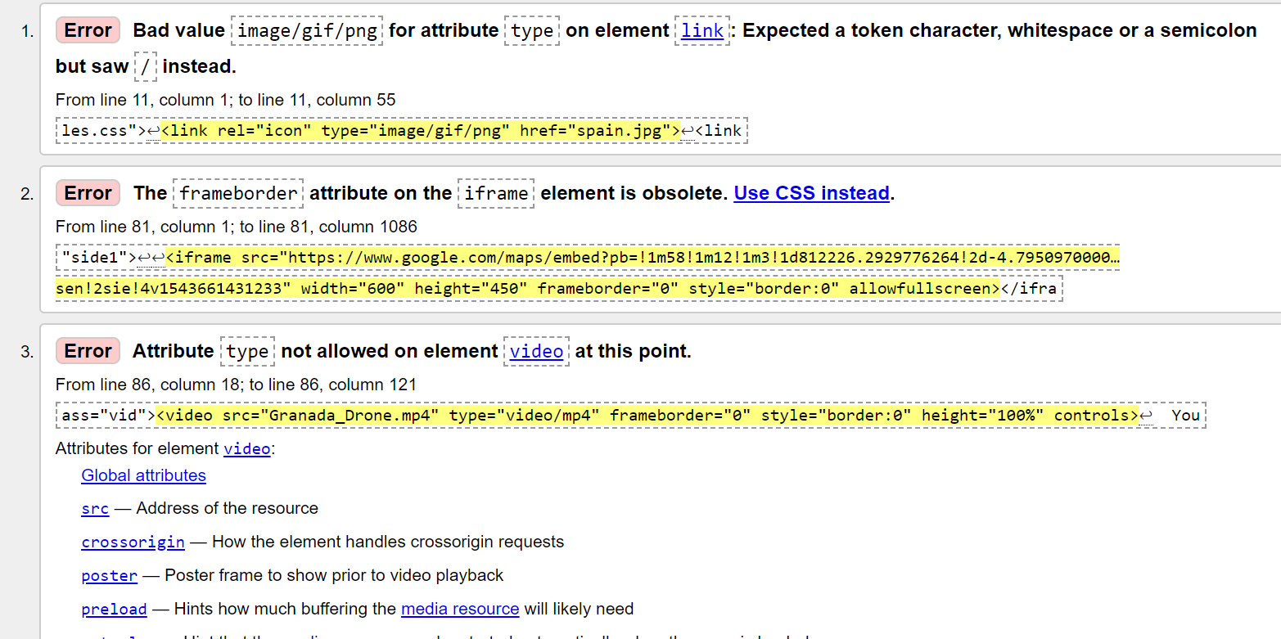

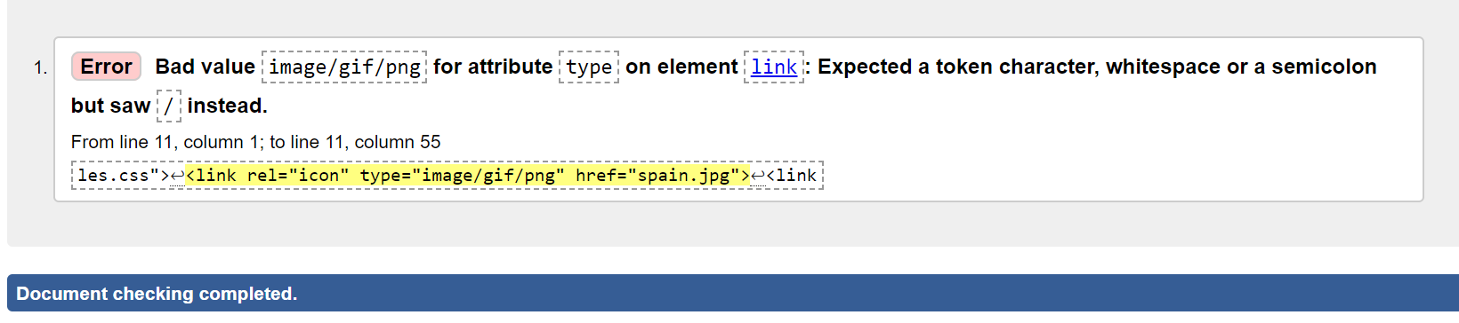

Testing gallery.html returned 6 errors with only 1 remaining after fixing, see below.

**Showing results for https://d17124464.github.io/gallery.html**

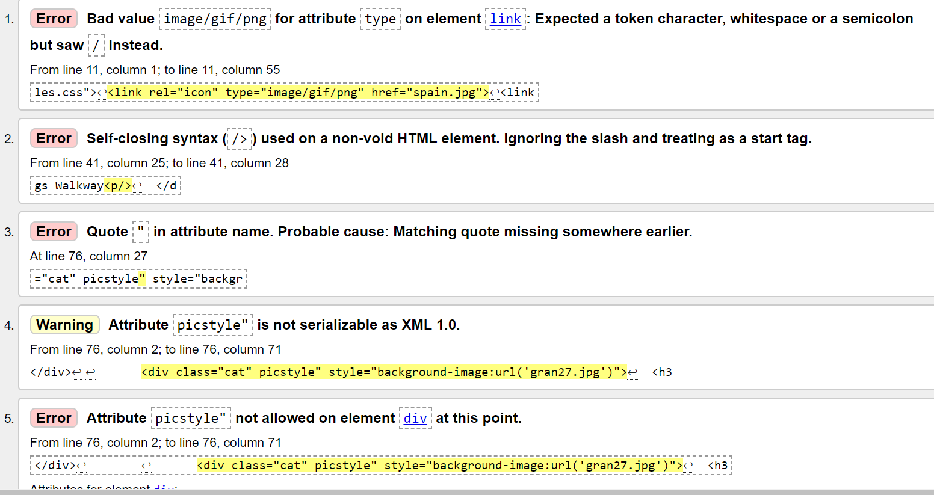

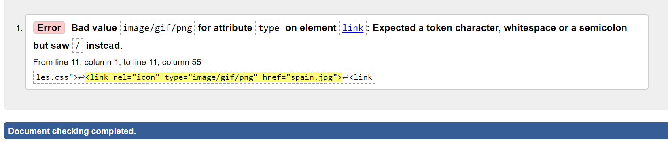

* I have tested the CSS code using CSS validator <https://jigsaw.w3.org/css-validator/>

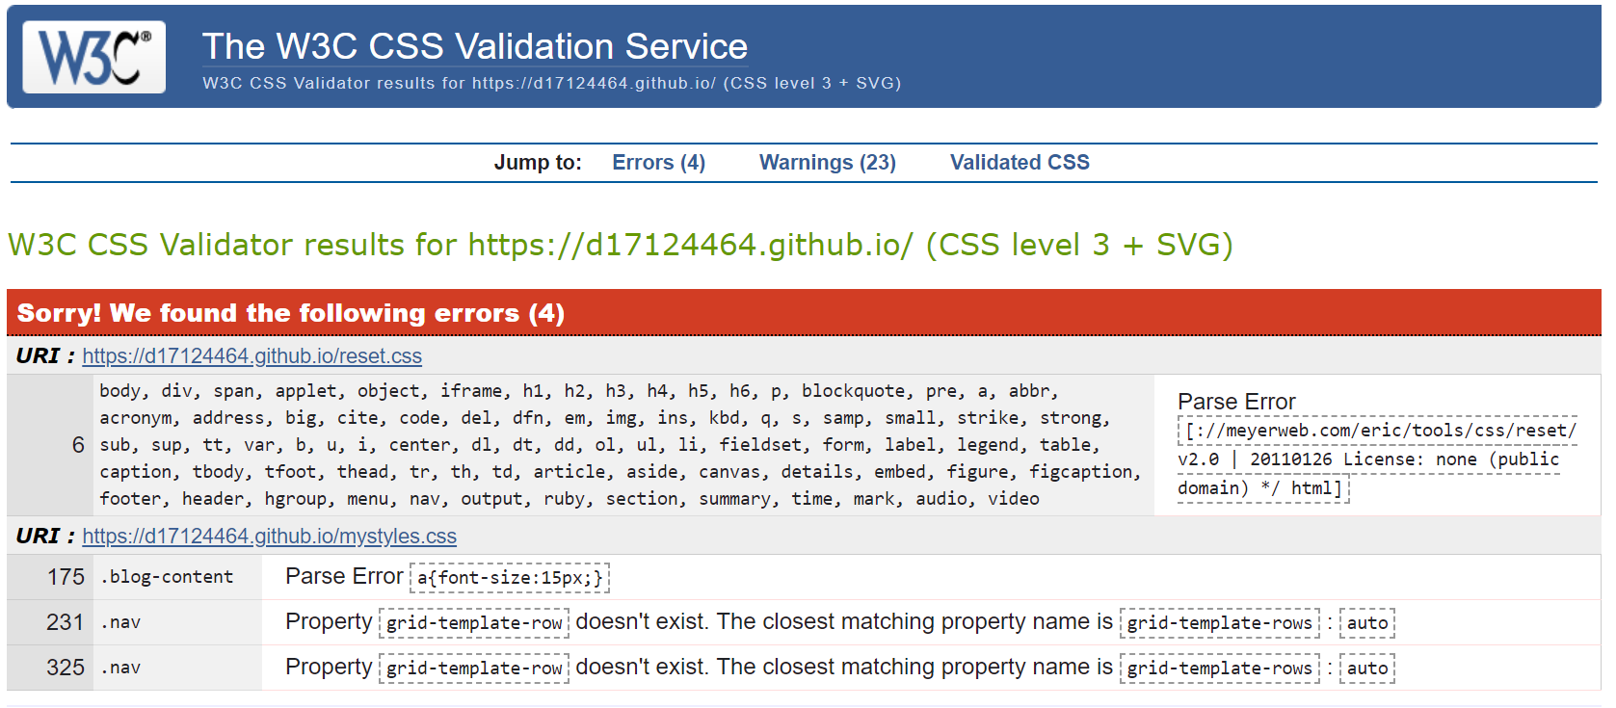

Note: the reset.css was included in an attempt to help the issue of CSS grid not rendering properly on Internet Explorer which unfortunately didn’t solve the problem.

[**https://medium.com/@elad/supporting-css-grid-in-internet-explorer-b38669e75d66**](https://medium.com/@elad/supporting-css-grid-in-internet-explorer-b38669e75d66)

Clickable images

Please note I have fully commented the index.html and mystyles.css files. The other html pages are based on index page.

A couple of my feedback comments said that they had been inspired to go to Andalucía!

Also one said friend emailed me through the javascript email facility to tell me this!

Many of questions with not as high as score is due to content or recommendations to friend and I feel that these issues are mainly due to time constraints of the project and in general the feedback in terms of the look and layout of the site were positive

Using check my links extension for Chrome.

Social Media links for facebook and twitter are highlighted as Invalid Links as

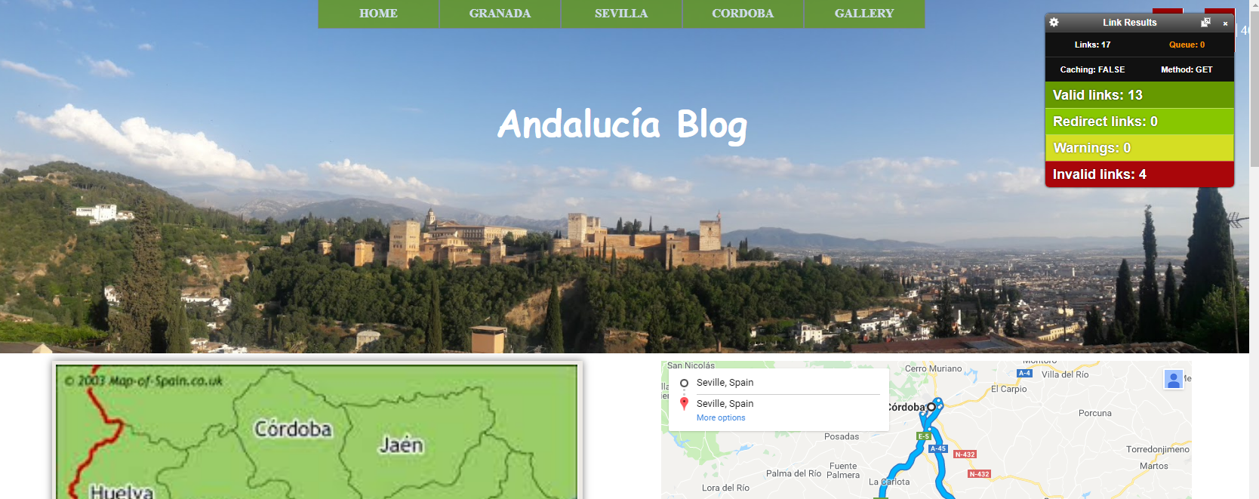

# Further Development

* Development – landscape and portrait via MQs
* Browser identification and code fixing
* Video sizing
* Navigation Bar – the Navigation Bar used is a minimal nav bar and I would have preferred to have a sandwich icon for the mobile version of the site. Also I would have liked to have a dropdown menu within the navigation bar which I began to develop but ran into problems when it came to the mobile screen so unfortunately I had to abandon this due to time constraints. See screenshot below.
* I used the same format on each page to adhere to consistency however I would like to have slightly different layouts on each page to allow for more flexibility of content. This would have meant creating more classes and adjusting the grid layout and therefore was beyond the time constraints of this project.
* Noscript tag included

